**Physics Research – Fundamentals Part II**

Prepared by: Brian (Chun Hung) Wu

*Appendix 1 – Interactive Diagrams*

*Appendix 2 – Topic and Sub-topic Tags*

**Energy**

Energy can exist in different forms, but they all share the same quality. They are:

* A scalar quantity (does not have a direction)
* Abstract and cannot always be perceived
* Given meaning through calculation
* A central concept in science

All forms of energy are either kinetic or potential.

**Kinetic Energy**

Kinetic Energy is the energy in motion, so any object that has motion (whether if it’s vertical or horizontal) has kinetic energy.

There are many forms of Kinetic energy – rotational (energy from rotation motion), vibrational (energy from vibrational motion), and translational (energy from motion from one location to another).

Kinetic energy depends on two variables – mass (m) and speed (v) of the object:

K = ½ * m* v^2

This indicates kinetic energy of an object is DIRECTLY PROPORTIONAL to the square of its speed, meaning:

* If there is a twofold of speed, the KE will increase by a factor of four
* If there is a threefold of speed, the KE will increase by a factor of nine
* And so on….

Simply put, the KE is dependent on the square of speed.

Kinetic Energy is described by magnitude since it is scalar and does not have a direction. Its standard metric units of measurement is Joule, which is equal to:

1 Joules = 1kg * m^2/s^2

**Potential Energy**

Objects can store energy as the result of its position. For example, the heavy ball of a demolition machine stores energy when held at an elevated position.

This stored energy of position is referred to as potential energy.

Another example would be a drawn bow: when it is at its usual position (not drawn) it has NO energy inside the bow. But when the position is altered from its usual equilibrium position, the bow stores energy by virtue of its position.

This stored energy of position energy is called Potential Energy. It is the stored energy of position possessed by the object.

[BOW DIAGRAM 1 – See Appendix 1]

**Gravitational Potential Energy**

Gravitational Potential Energy is the energy stored in an object as a result of its vertical position or height.

Energy is stored as a result of gravitational attraction of Earth for the object.

It is dependent on two variables: the height of the object in which it is suspended/raised (h), and the mass of the object (m).

Their relationship is expressed in this equation:

PE = m * g * h

(*with g being the gravitational field strength (9.8N/kg on Earth))*

This can be interpreted into two ways:

* The greater the mass, the more gravitational potential energy there is
* The higher the object is elevated, the greater the gravitational potential energy

To determine GPE, a zero height position must be first assigned. (it can be the ground, the table, whatever you decide as a relative point).

**Elastic Potential Energy**

Elastic potential energy is the energy stored in elastic materials as the result of their stretching or compressing.

It can be stored in rubber bands, bungee cords, trampolines, springs, an arrow drawn into a bow, etc.

The amount of elastic potential energy stored in such a device is related to the amount of stretch of the device - the more stretch, the more stored energy.

In the case of springs, it is a device that stores EPE due to its ability to compress and stretch.

According to **Hooke's Law**: F = -k * x

*Where F is the force, k is the spring constant and x is the amount of compression.*

This means the force required to stretch the spring will be directly proportional to the amount of stretch.

That means the work done to stretch the spring a distance x is:

Work = ΔPE = 1/2 * k * x^2

*Where k is the spring constant and x is the amount of compression.*

*[SPRING DIAGRAM 2 – Appendix 1]*

To summarize, potential energy is the energy that is stored in an object due to its position relative to some zero position.

* An object possesses **gravitational potential energy** if it is positioned at a height above (or below) the zero height.
* An object possesses **elastic potential energy** if it is at a position on an elastic medium other than the equilibrium position.

**Mechanical Energy**

Mechanical energy is the energy that is possessed by an object due to its motion or due to its position.

Mechanical energy can be either **kinetic energy** (energy of motion) or **potential energy** (stored energy of position).

Objects have mechanical energy if they are in motion and/or if they are at some position relative to a zero potential energy position.

**Total Mechanical Energy**

The total amount of mechanical energy is merely the sum of the potential energy and the kinetic energy:

TME = PE + KE

Since there is two types of Potential Energy, the equation can be rewritten as:

TME = PE (gravitational) + PE (elastic) + KE

**Hooke’s Law**

One of the properties of elasticity is that it takes about twice as much force to stretch a spring twice as far.

That linear dependence of displacement upon stretching force is called Hooke's Law:

F = -k * x

*Where F is the force, k is the spring constant and x is the amount of compression.*

[Hooke’s Law Diagram 3 – Appendix 1]

**Work**

There are three key ingredients to work - force, displacement, and cause.

In order for a force to qualify as having done work on an object, there must be a displacement and the force must cause the displacement.

Examples: a horse pulling a plow through the field, a father pushing a grocery cart down the aisle of a grocery store, a weightlifter lifting a barbell above his head, etc.

The work equation is:

W = F * d * cos Θ

*Where F is force, d is the displacement, and angle (theta) is the angle between the force and the displacement vector*

**Momentum and Collisions**

A collision between two objects is a short-term contact interaction.

The time taken for the interaction is very short but not instantaneous (even though it might seem so to the naked eye).

An object which is moving has momentum. In equation form:

p = m * v

*Where p is the momentum, m is the mass and v is the velocity.*

**Impulse-Momentum Change**

In a collision, a force acts upon an object for a given amount of time to change the object's velocity.

The product of force and time is known as impulse. The product of mass and velocity change is known as momentum change.

Impulse = Momentum Change

F * T = M * ΔV

*Where F is the force, t is the time, m is the mass and v is the velocity.*

**The Momentum Conservation Principle**

In a collision between two objects, each object is interacting with the other object. The interaction involves a force acting between the objects for some amount of time.

Since a collision is governed by Newton’s Law of Motion, it can be applied to the analysis of the situation.

In a collision between object 1 and object 2, the force exerted on object 1 (F1) is equal in magnitude and opposite in direction to the force exerted on object 2 (F2). In equation form:

F1 = -F2

Now in any given interaction, the forces which are exerted upon an object act for the same amount of time. You can't contact another object and not be contacted yourself (by that object).

And the duration of time during which you contact the object is the **SAME** as the duration of time during which that object contacts you, which means:

T1=T2

Using mathematical logic, if A = -B, and C=D, then A *C = -B * D.

Hence, if F1 = -F2 and T1 = T2, then:

F1 * T1 = -F2 * T2

Since we established before that the impulse (F*T) is equal to momentum change (m* ΔV), we can rewrite the equation as:

M1* ΔV1 = -m2* ΔV2

The amount of momentum gained by one object is **EQUAL** to the amount of momentum lost by the other object.

The total amount of momentum possessed by the two objects does not change. Momentum is simply transferred from one object to the other object.

The formula can be rewritten into a commonly used equation:



*Where m is the mass and v is the velocity.*

**Elastic and Inelastic Collisions**

A perfectly elastic collision is defined as one in which there is no loss of **kinetic energy** in the collision.

An inelastic collision is one in which part of the kinetic energy is changed to some other form of energy in the collision.

Any macroscopic collision between objects will convert some of the kinetic energy into internal energy and other forms of energy, so **no large scale impacts are perfectly elastic.**

Momentum is conserved in inelastic collisions, but one cannot track the kinetic energy through the collision since some of it is converted to other forms of energy.

**Elastic Collisions**

Anyone who plays pool has observed elastic collisions.

Some kinetic energy is converted into sound energy when pool balls collide—otherwise, the collision would be silent—and a very small amount of kinetic energy is lost to friction.

However, the dissipated energy is such a small fraction of the ball’s kinetic energy that we can treat the collision as elastic.

[POOL BALL EXAMPLE 4 – Appendix 1]

Assume elastic collision between two particles of mass m1 and m2, respectively.

The velocities of the particles before the elastic collision are v1 and v2, respectively.

The velocities of the particles after the elastic collision are v1’ and v2’.

Applying the law of conservation of kinetic energy, we find:



Applying the law of conservation of linear momentum:



**Inelastic Collisions**

A completely inelastic collision, also called a “perfectly” or “totally” inelastic collision, is one in which the colliding objects stick together upon impact.

As a result, the velocity of the two colliding objects is the same after they collide.

Because v1’ = v2’ = v’, it is possible to solve problems asking about the resulting velocities of objects in a completely inelastic collision using only the law of conservation of momentum.

[Pool Ball Diagram 2 – Appendix 1]

**Kepler’s Three Laws**

Kepler discovered three laws of motion of planets by analyzing empirical data:

1. Planets move in elliptical orbits with the sun at one focus of the ellipse (Law of Eclipses)
2. A line connecting the sun and a planet sweeps out equal areas in equal amounts of time (Law of Equal Area)
3. The square of the orbital period of a planet is proportional to the cube of the semi-major axis of the ellipse. (Law of Harmonies)

**The Law of Ellipses**

Kepler's first law - sometimes referred to as the law of ellipses - explains that planets are orbiting the sun in a path described as an ellipse.

An ellipse is a special curve in which the sum of the distances from every point on the curve to two other points is a constant.

The two other points are known as the **foci** of the ellipse.

The law is pretty straightforward – it is to state that all planets orbit the sun in a path that resembles an ellipse, with the sun being located at one of the foci of that ellipse.

**The Law of Equal Areas**

Kepler's second law - sometimes referred to as the law of equal areas - describes the speed at which any given planet will move while orbiting the sun.

The speed at which any planet moves through space is constantly changing.

A planet moves fastest when it is closest to the sun and slowest when it is furthest from the sun.

Yet, if an imaginary line were drawn from the center of the planet to the center of the sun, that line would sweep out the same area in equal periods of time.

[Law of Equal Area Diagram 6 – Appendix 1]

As can be observed in the diagram, the areas formed when the earth is closest to the sun can be approximated as a **wide but short triangle**; whereas the areas formed when the earth is farthest from the sun can be approximated as a **narrow but long triangle**.

**These areas are the same size**.

Since the base of these triangles are shortest when the earth is farthest from the sun, the earth would have to be moving more slowly in order for this imaginary area to be the same size as when the earth is closest to the sun.

**The Law of Harmonies**

Kepler's third law - sometimes referred to as the law of harmonies - **compares the orbital period and radius of orbit of a planet to those of other planets.**

Unlike Kepler's first and second laws that describe the motion characteristics of a single planet, the third law makes a comparison between the motion characteristics of different planets.

The comparison being made is that the ratio of the squares of the periods to the cubes of their average distances from the sun is the same for every one of the planets.

As an illustration, consider the orbital period and average distance from sun (orbital radius) for Earth and mars as given in the table below:

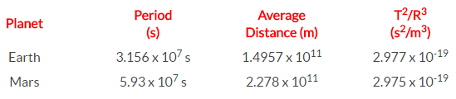

Observe that the T2/R3 ratio is the same for Earth as it is for Mars.

In fact, if the same T2/R3 ratio is computed for the other planets, it can be found that this ratio is nearly the same value for all the planets (see table below).

Amazingly, every planet has the same T2/R3 ratio.

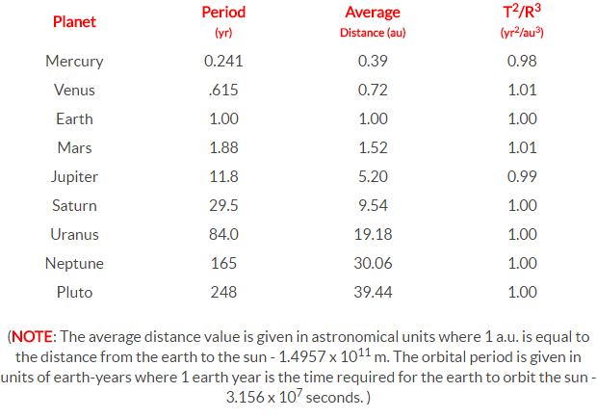

Kepler's third law provides an accurate description of the period and distance for a planet's orbits about the sun.

Additionally, the same law that describes the T2/R3 ratio for the planets' orbits about the sun also accurately describes the T2/R3 ratio for any satellite (whether a moon or a man-made satellite) about any planet.

**Gravitational and Orbital Motion**

**Orbital Speed Equation**

Consider a satellite with mass M(sat) orbiting a central body with a mass of mass M(Central).

The central body could be a planet, the sun or some other large mass capable of causing sufficient acceleration on a less massive nearby object.

If the satellite moves in circular motion, then the net centripetal force acting upon this orbiting satellite is given by the relationship:

Fnet = (M(sat) * v2 ) / R

This net centripetal force is the result of the gravitational force that attracts the satellite towards the central body and can be represented as

Fgrav = ( G * M(sat) * M(Central) ) / R2

Since Fgrav = Fnet, the above expressions for centripetal force and gravitational force can be set equal to each other. That means:

(M(sat) * v2) / R = (G * M(sat) * M(Central)) / R2

The mass of the satellite is present on both sides of the equation, so it can be canceled by dividing through by M(sat).

Then both sides of the equation can be multiplied by R, leaving the following equation.

v2 = (G * M(Central)) / R

Taking the square root of each side, leaves the following equation for the velocity of a satellite moving about a central body in circular motion

V = sqrt((G * M(Central)) / R)

*where G is 6.673 x 10-11 N•m2/kg2, M(central) is the mass of the central body about which the satellite orbits, and R is the radius of orbit for the satellite.*

**The Acceleration Equation**

Similar reasoning can be used to determine an equation for the acceleration of our satellite that is expressed in terms of masses and radius of orbit.

The acceleration value of a satellite is equal to the acceleration of gravity of the satellite at whatever location that it is orbiting. The equation for the acceleration of gravity was given as

G = (G * M(central))/R2

Thus, the acceleration of a satellite in circular motion about some central body is given by the following equation

A = (G * M(central))/R2

*Where G is 6.673 x 10-11 N•m2/kg2, M(central) is the mass of the central body about which the satellite orbits, and R is the average radius of orbit for the satellite.*

**Orbital Period Equation**

The final equation that is useful in describing the motion of satellites is Newton's form of Kepler's third law.

Since the logic behind the development of the equation has been presented elsewhere, only the equation will be presented here.

The period of a satellite (T) and the mean distance from the central body (R) are related by the following equation:



*where T is the period of the satellite, R is the average radius of orbit for the satellite (distance from center of central planet), and G is 6.673 x 10-11 N•m2/kg2.*

**Appendix 1: Interactive Diagrams**

Diagram 1 – Bow Diagram

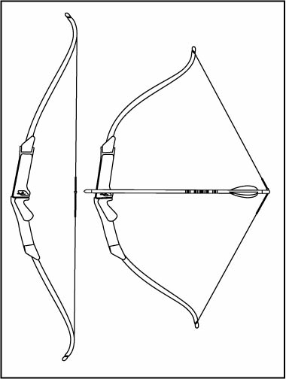

Diagram 2 – Spring Diagram

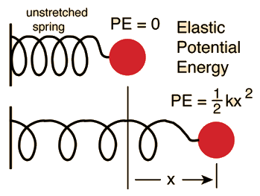

Diagram 3 – Hooke’s Law

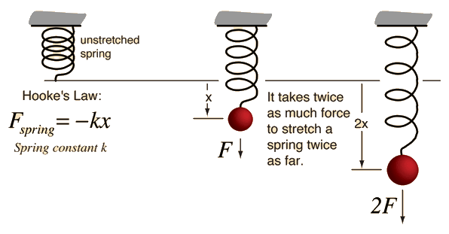

Diagram 4 – Elastic Collision Pool Ball

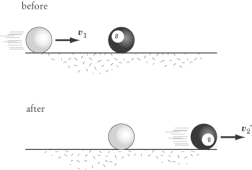

Diagram 5 – Inelastic Collision Gumball

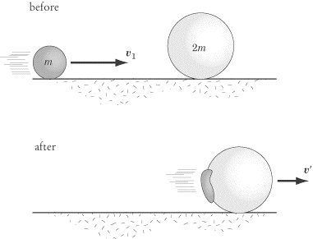

Diagram 6 – Law of Equal Areas

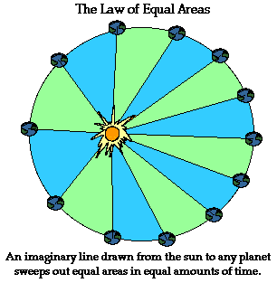

**Appendix 2: Tags (each around 10-15)**

**Energy**

* **Kinetic**: KE, kinetic, energy, rotational, transitional, orbital, speed, velocity, k, magnitude, scalar, joules, motion, vertical, horizontal
* **Potential**: PE, potential, Gravitational, elastic, Hooke, law, spring, compress, spring, height, mass, gravity, zero, height, suspend, energy
* **Mechanical**: total, mechanical, KE, PE, kinetic, potential, energy, sum, zero, position, work

**Work** – force, mass, displacement, cause, cosine, theta, energy, motion, vector, Work

**Momentum and Collusions**: conservation, momentum, collusion, law, impulse, momentum change, principle, transfer, possess, mass, velocity, force, time, motion, Newton

**Collusions** -> Elastic and Inelastic Collusions: kinetic energy, KE, kinetic, energy, inelastic, elastic, perfectly elastic, collusion, internal, mass, velocity, momentum, conservation

**Kepler’s Laws**

* **Eclipse**: eclipse, orbit, orbital, Kepler, first, law, foci, earth, sun, motion, gravity, circular, planets, focus, path
* **Equal Area**: speed, planet, earth, sun, orbit, orbital, Kepler, second, law, equal, area, base, same, triangle, time
* **Harmonies**: radius, planet, Mars, earth, sun, compare, harmony, motion, period, ratio, Kepler, third, law, equal, relative

**Gravitational and Orbital Motion:** satellite, orbital, mass, circular, acceleration, Newton, law, velocity, force, gravitational, motion, speed, period, Kepler, third, gravity